Collaboration Diagram:
Admin Login Collaboration Diagram:
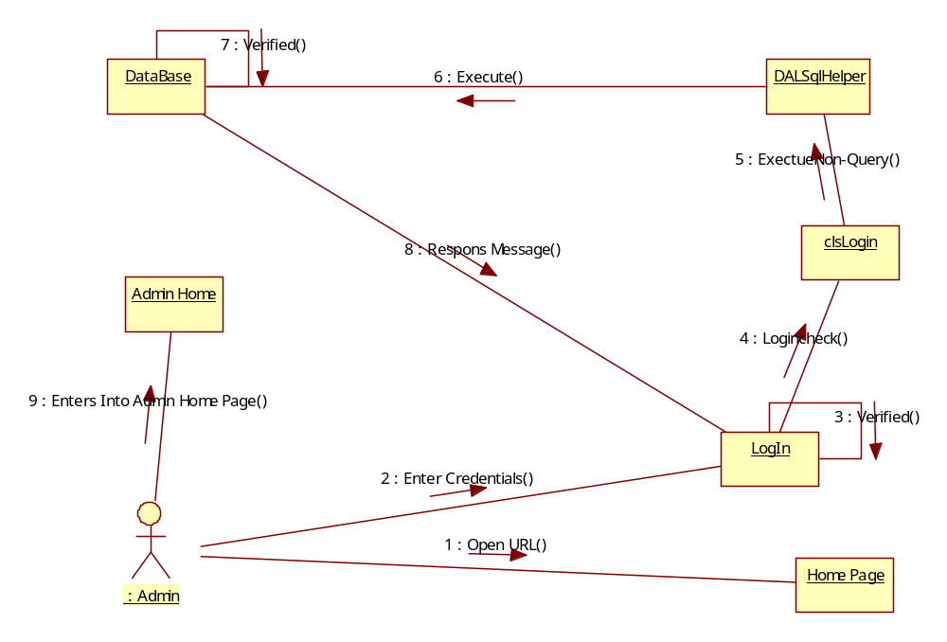
Add State Collaboration Diagram:
: Admin
LogIn
Admin Home
Add State
clsState
Dal SqlHelper
Database
1 : Enter Credentials()
2 : Verified()
3 : Enters Into Admin Home Page()
4 : Enters state Details()
5 : Add state()
6 : Execute NonQuery()
7 : Execute()
8 : Response Message()

Add District Details Collaboration Diagram:
: Admin
LogIn
Admin Home
Add District
clsState
Dal SqlHelper
Database
1 : Enter Credentials()
2 : Verified()
3 : Enters Into Admin Home Page()
4 : Enters District Details()
5 : Add Floor()
6 : Execute NonQuery()
7 : Execute()
8 : Response Message()

City Collaboration Diagram:
: Admin
LogIn
Admin Home
Add City
clsCity
Dal SqlHelper
Database
1 : Enter Credentials()
2 : Verified()
3 : Enters Into Admin Home Page()
4 : Enters City Details()
5 : Add Asset()
6 : Execute NonQuery()
7 : Execute()
8 : Response Message()

Add Distributor Collaboration Diagram:
: Admin
LogIn
Admin Home
Add Distributor
clsUser
Dal SqlHelper
Database
1 : Enter Credentials()
2 : Verified()
3 : Enters Into Admin Home Page()
4 : Enters Distributor Details()
5 : Add Invoice()
6 : Execute NonQuery()
7 : Execute()
8 : Response Message()

Distributor View User Requests Collaboration Diagram:
LogIn
Home
View requests
clsUser
Dal SqlHelper
Database
: Distributor
1 : Enter Login Details()
2 : Verified()
3 : Get Home Page()
4 : Select Connection Request()
5 : Show connection Request()
6 : ExecuteDataset()
7 : Execute()
8 : Verified()
9 : View Reports()
: Admin
LogIn
Admin Home
Add Gas cylinders
clsAdmin
Dal SqlHelper
Database
1 : Enter Credentials()
2 : Verified()
3 : Enters Into Admin Home Page()
4 : Enters Gas Cylinders Details()
5 : Add Cylinders()
6 : Execute NonQuery()
7 : Execute()
8 : Response Message()

Admin View Reports:
